## Mary A. Marion's Home Page

## I Specialize in Applying Mathematical Statistics,

**DOE, Linear Models, Analysis, and Machine Learning.**

#### © Copyright 2000 Mary A. Marion

**To contact me, send email to** [***mmstat7@gmail.com***](mailto:mmstat7@gmail.com)

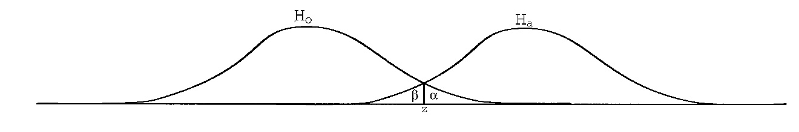

**What do I do?**

**I am a statistician who works with physical science and engineering data to resolve questions of product effectiveness.   
I also have experience with environmental risk assessment and biostatistics.**

**RIT Graduate 2023**